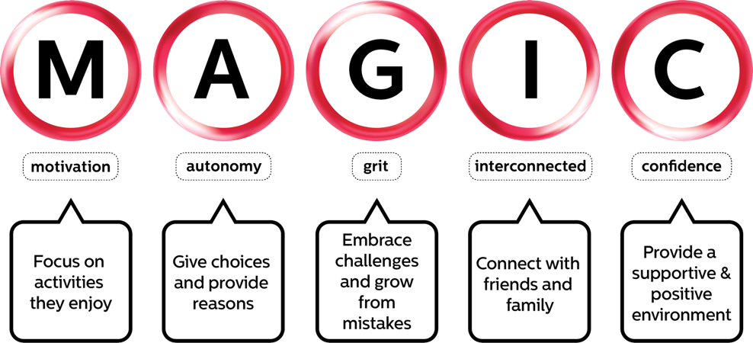
Family Action Plan

Building your child’s motivation and confidence, one small habit at a time.

Child’s name: ________________________________ Date: ______________

The MAGIC framework turns the building blocks of physical literacy into five everyday things you can do as a parent. Pick one or two ideas under each heading that suit your child and your week, write them below, and revisit the plan as your child grows. Small, repeated moments matter more than big one-off efforts.

MAGIC element | What can I say, do or try?
Motivation
I will encourage enjoyment by…
Autonomy
I will offer choices and reasons by…
Grit
I will build resilience and a growth mindset by…
Interconnected
I will share active moments and model taking part by…
Confidence
I will create a supportive, positive environment by…
More to explore: Free family downloads | Physical literacy & MAGIC for families

